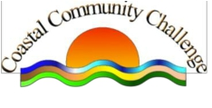

COASTAL COMMUNITIES CHALLENGE

BUDGET SPEND MAY 2019 – APRIL 2020

Amount drawn down £214,885.00

Spend
Communications
Corporate Activities (inc room hire
For office and Community Pods)

£ 2,807.14
£ 3,858.97

Events £ 7,801.90

Grants £ 40,781.26

Arts & Heritage £ 6,100.00

Health £ 10,600.00

Environment £ 12,415.01

Community Cohesion £ 7,225.00

Loan Fund £ 8,000.00

Children/Youth £ 5,990.00

Employment/skills, investment and
Education

£ 9,500.00

Adult Services and poverty £26,250.00

£141,329.28

Balance held £ 73,555.72

